1. First step is to download the server 2019 from Microsoft Windows Insider.

<https://insider.windows.com/en-us/for-business-getting-started-server/>

To download server 2019 , you need to register and after registration you will be able to download Windows Insider Preview

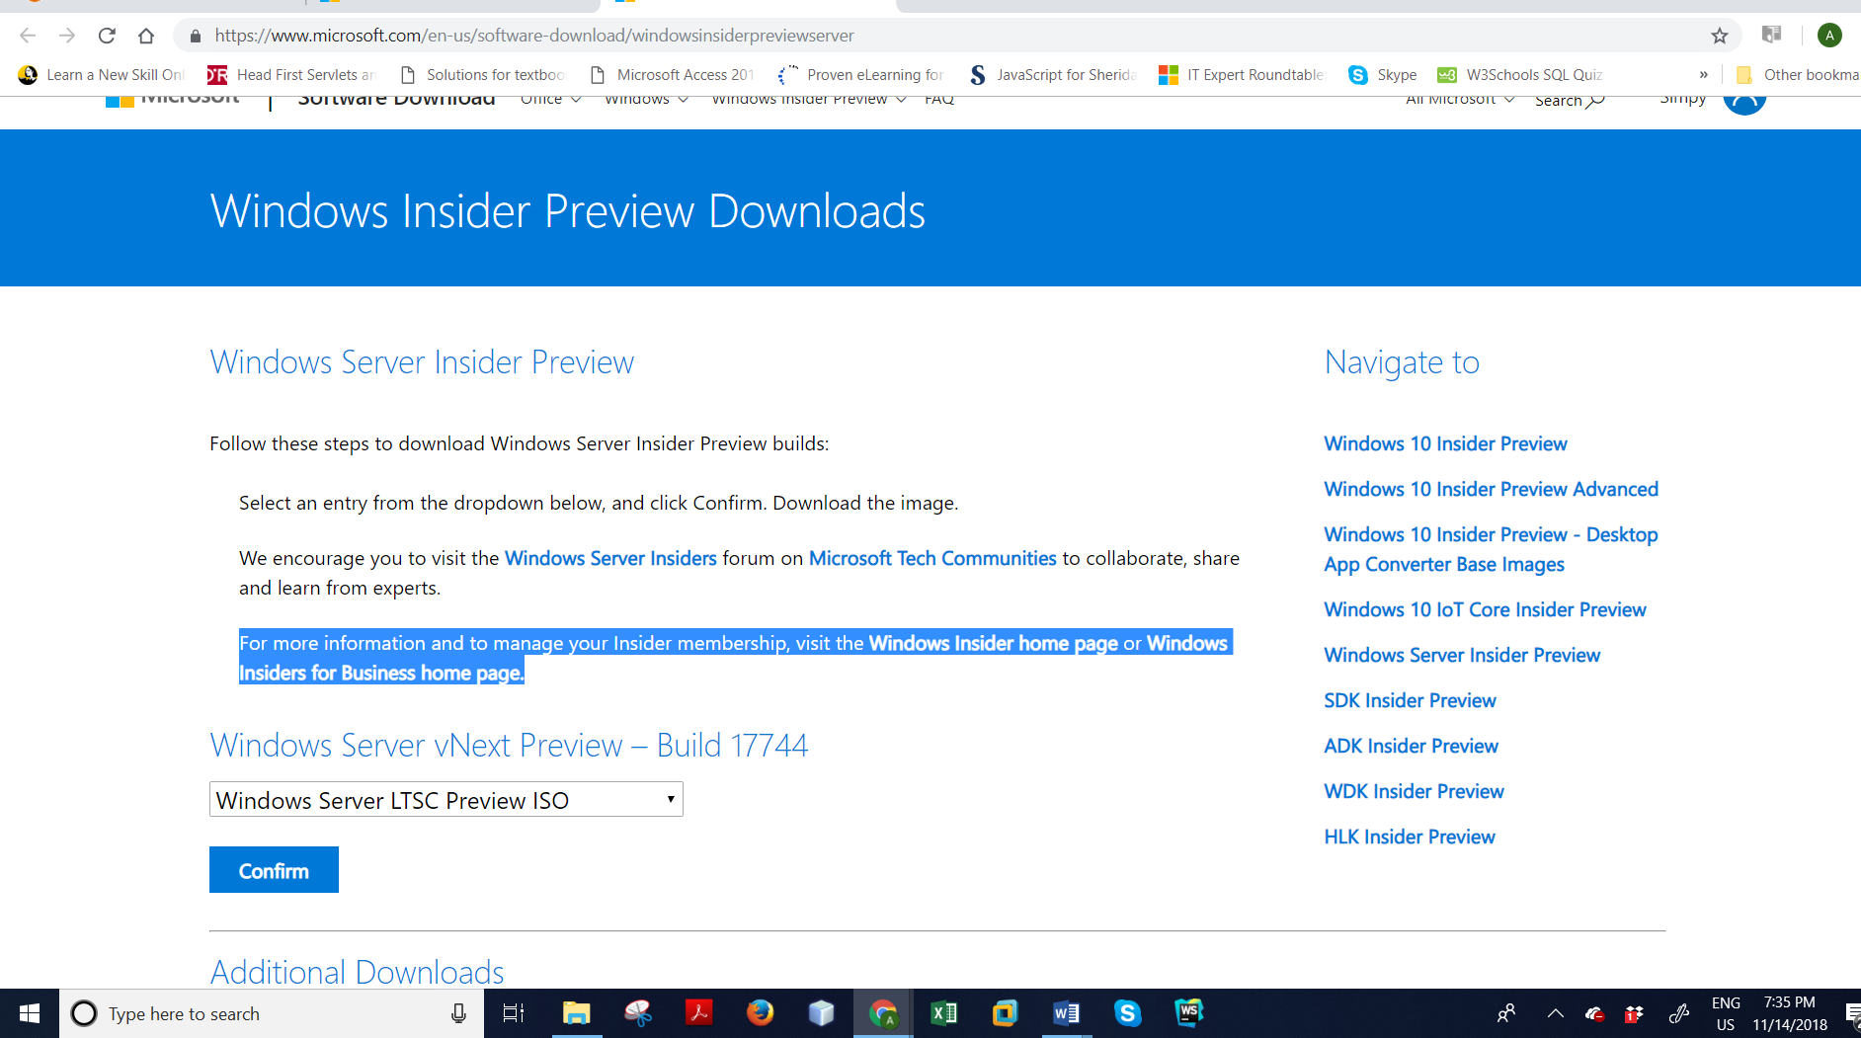

1. Now, click confirm and select language

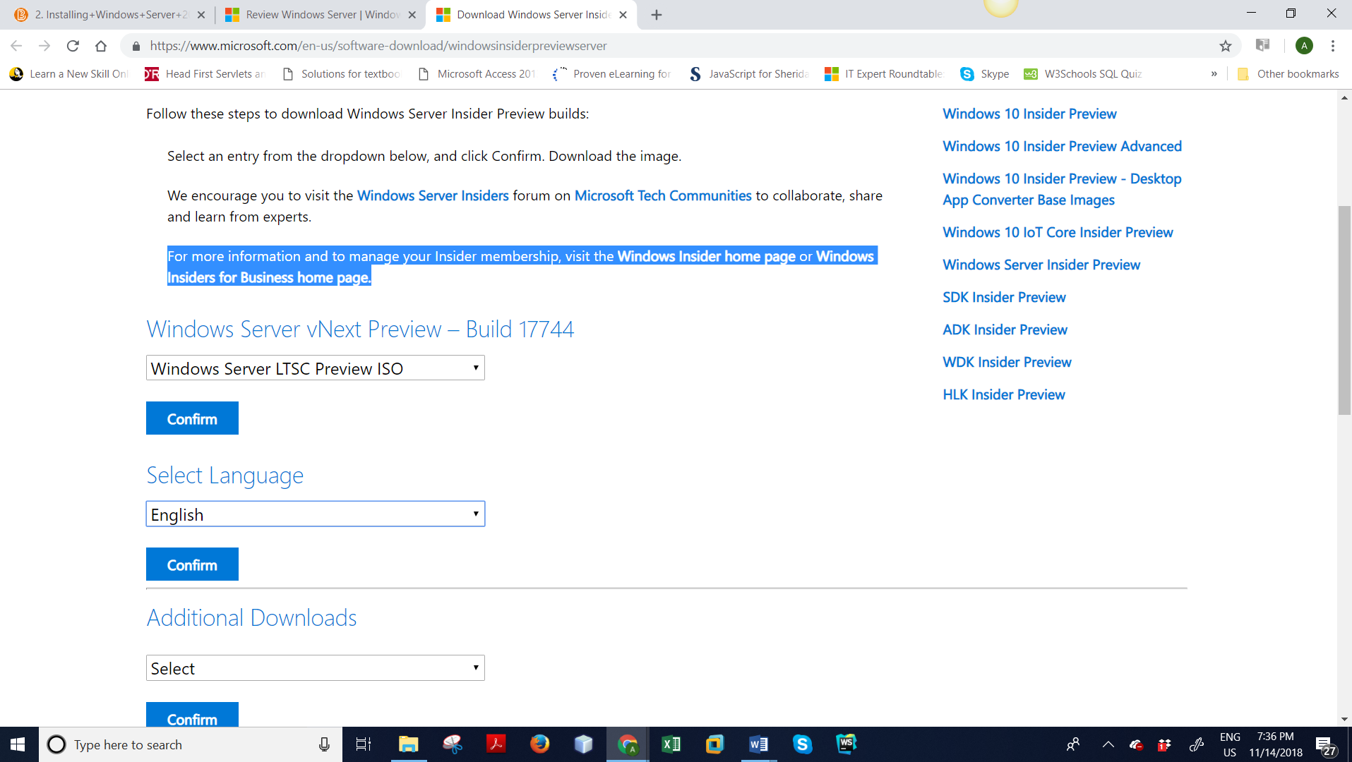

3) Click on Download Now

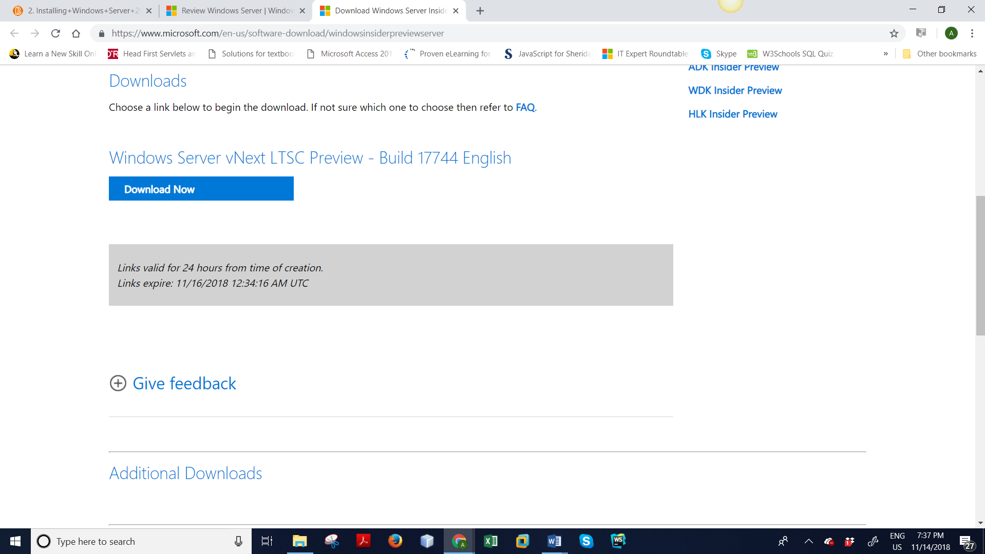

4) Now start VMWare and create new virtual machine

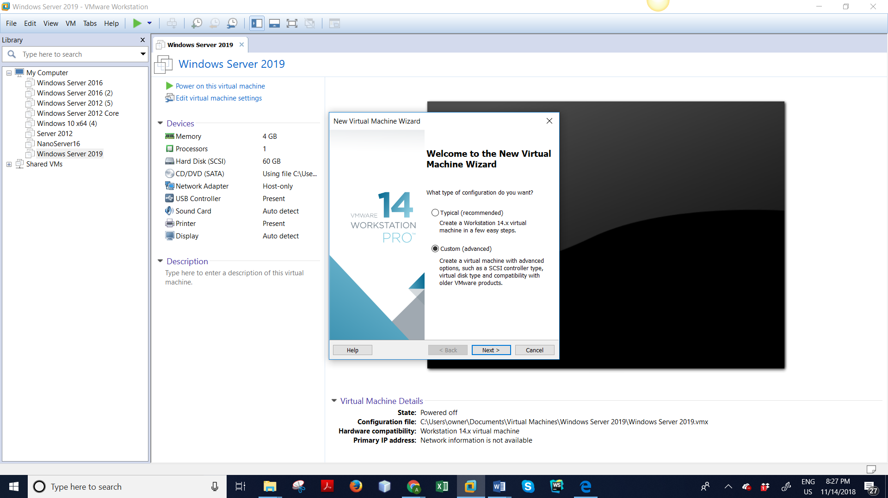

5) Select Custom and click next and then select the shown below

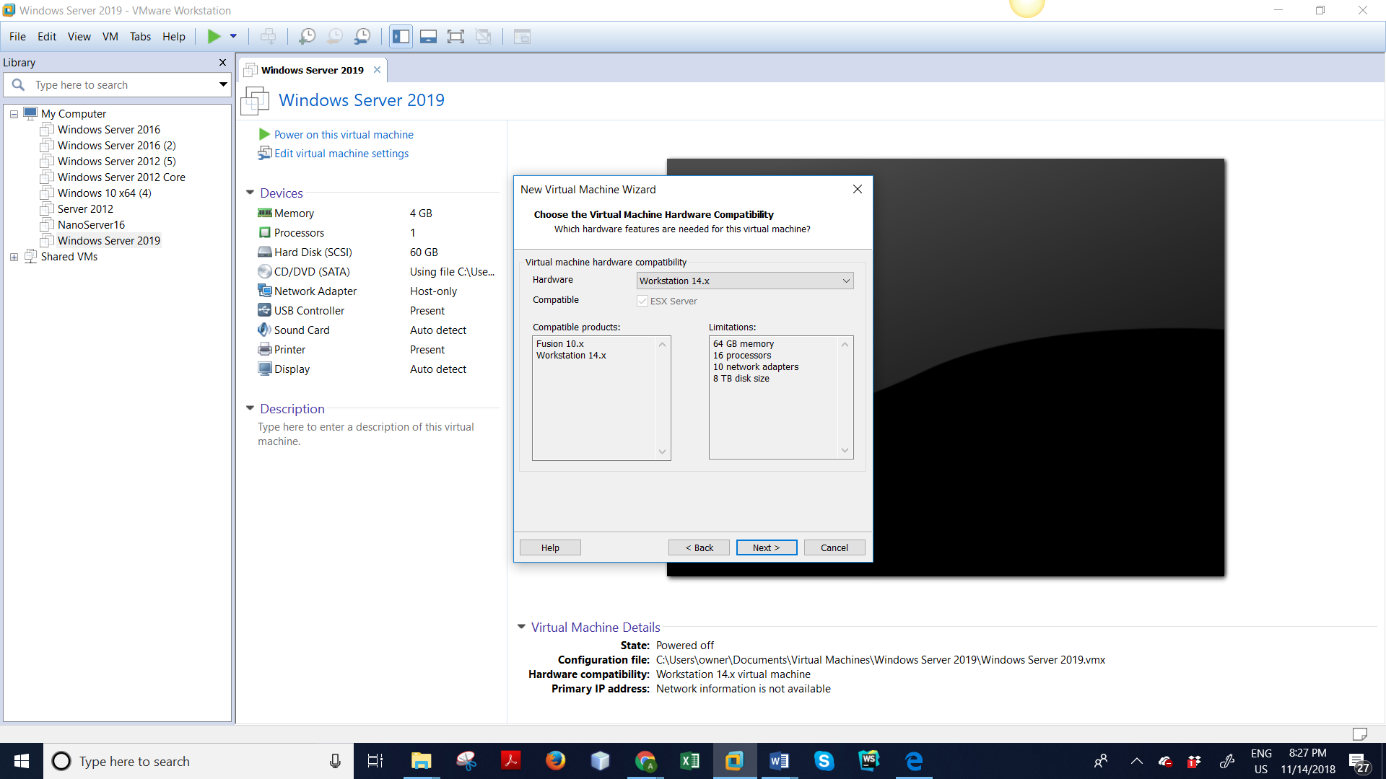

6) Click next after select I will install operating system later on

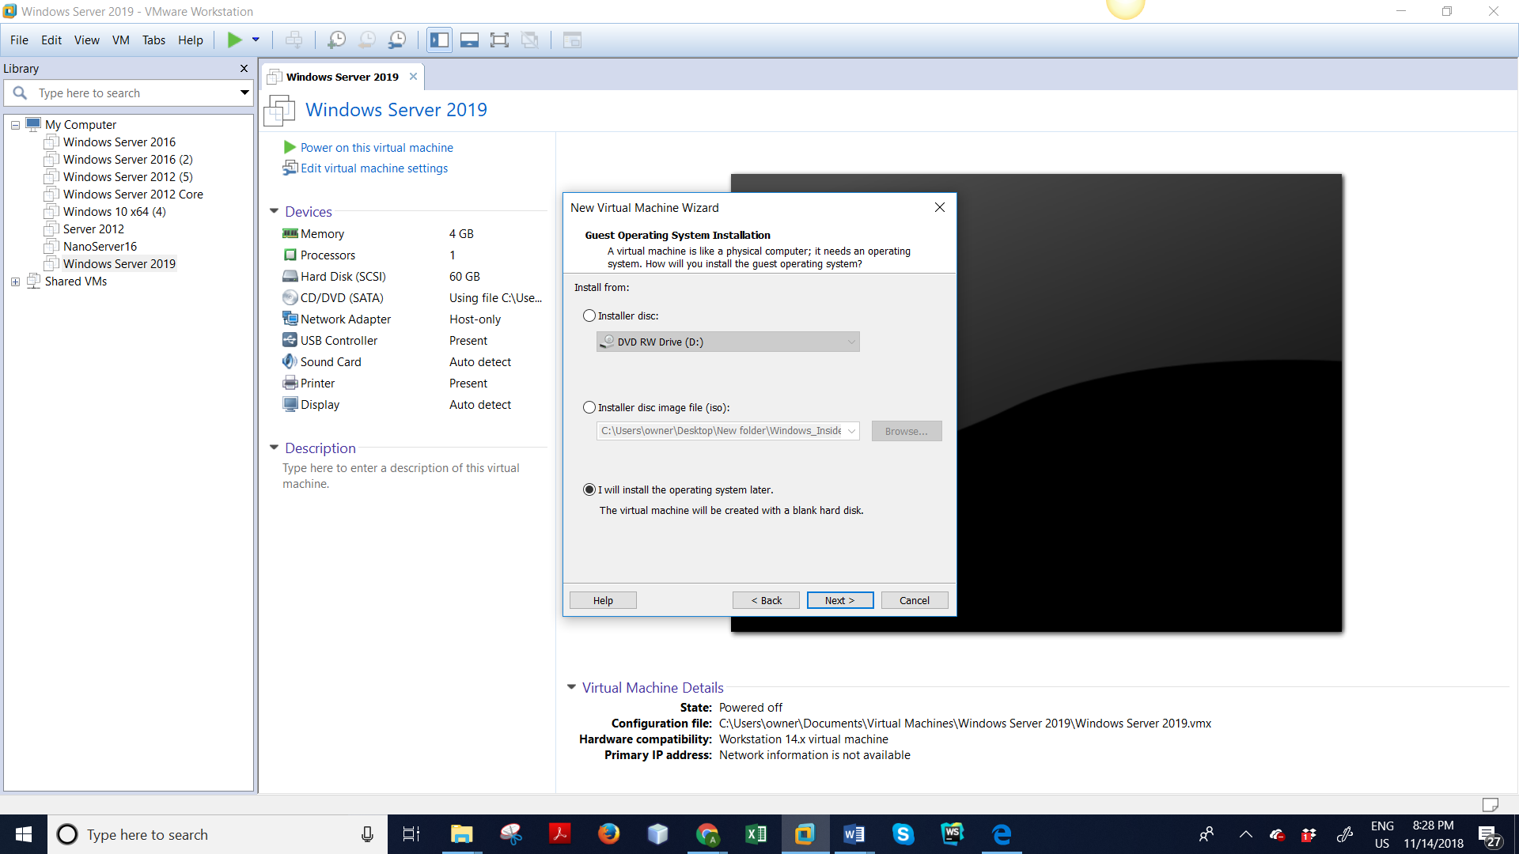

7) Click next after selecting Microsoft Windows

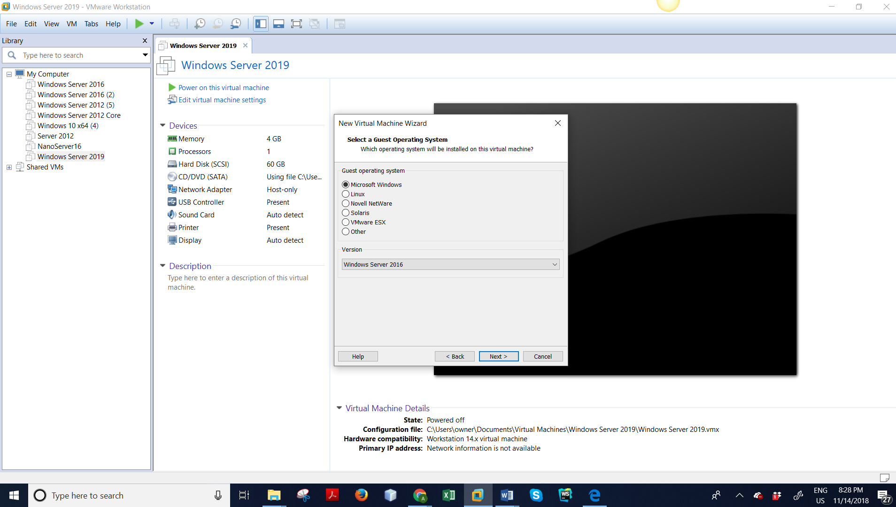

8) Now name the ‘Server 2019’ and click next

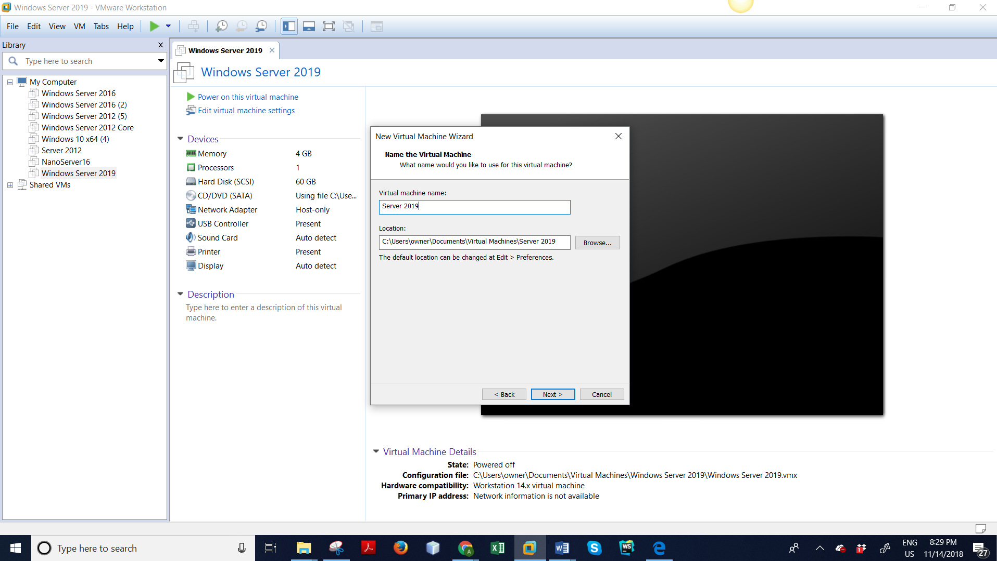

9) Select BIOS and click next

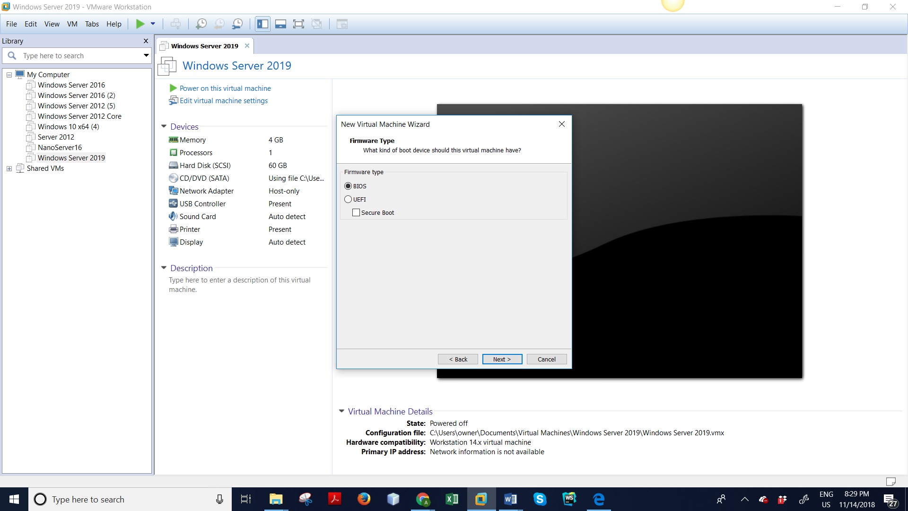

10) Now select number of processors 1 and core processors 2 and click next

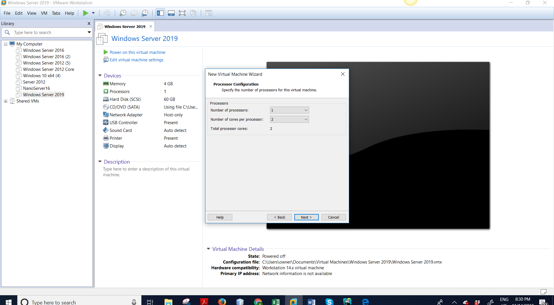

Now check memory size and should be 2 GB and click next

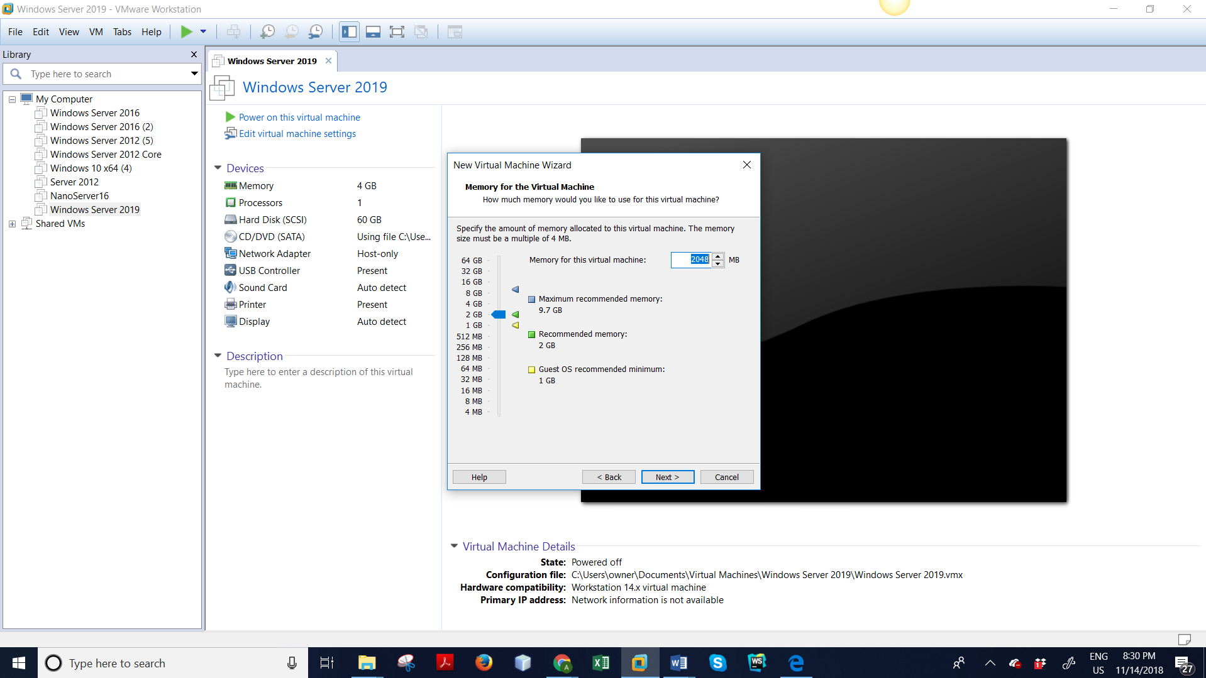

Now click on use network …. And click next

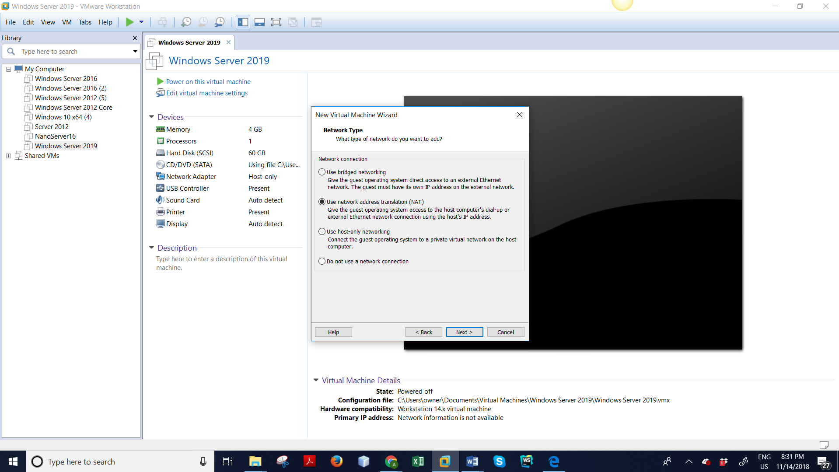

Again make selection of third radio button ( as per image ) and click next

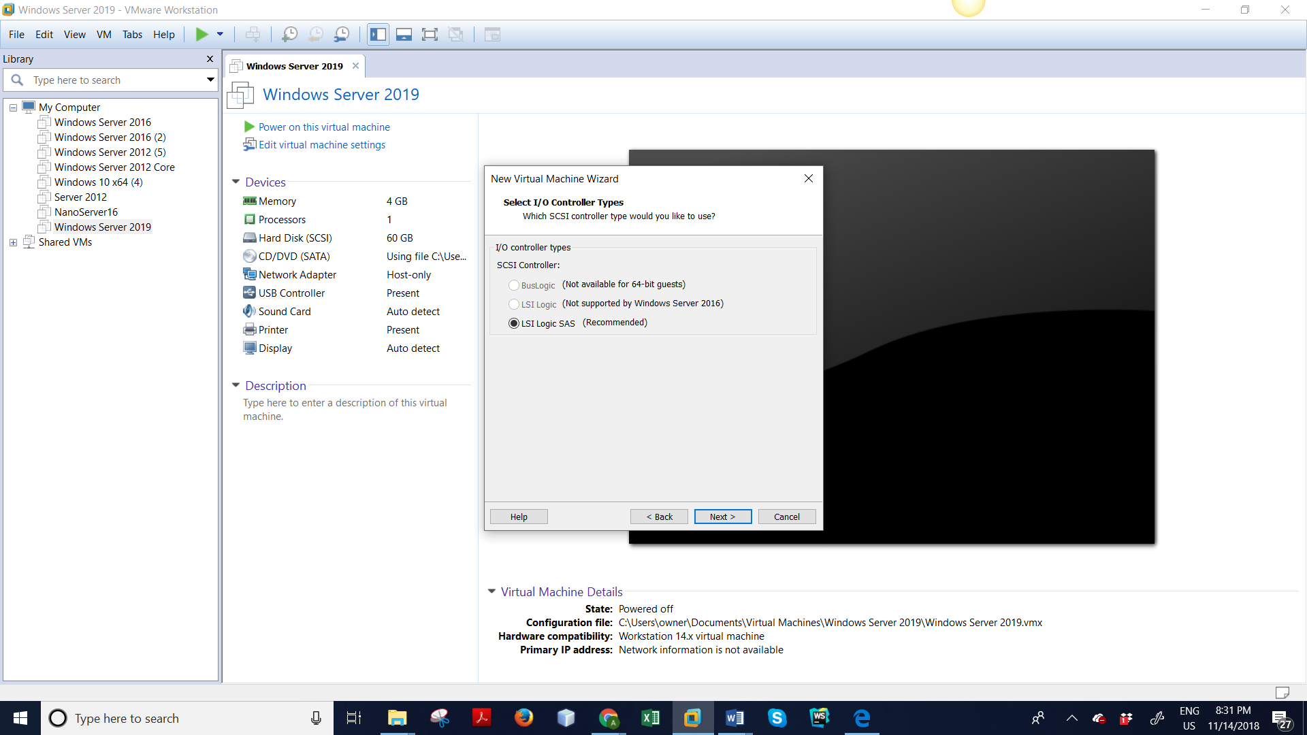

Now select SCII( Recommended ) and click next

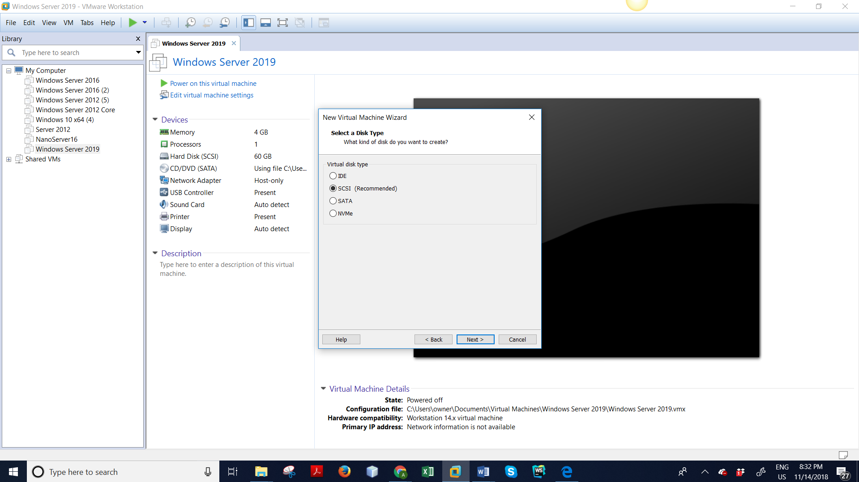

Now select create a new virtual disk and click next

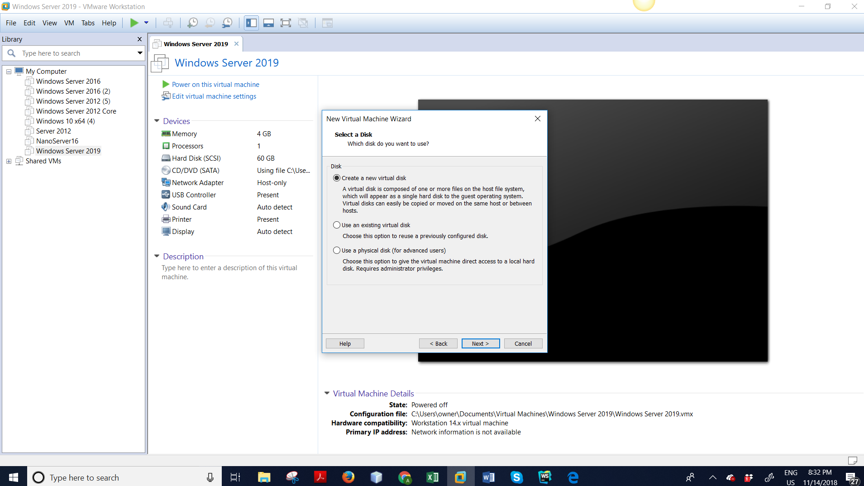

Now select minimum disk capacity 60 GB and click next

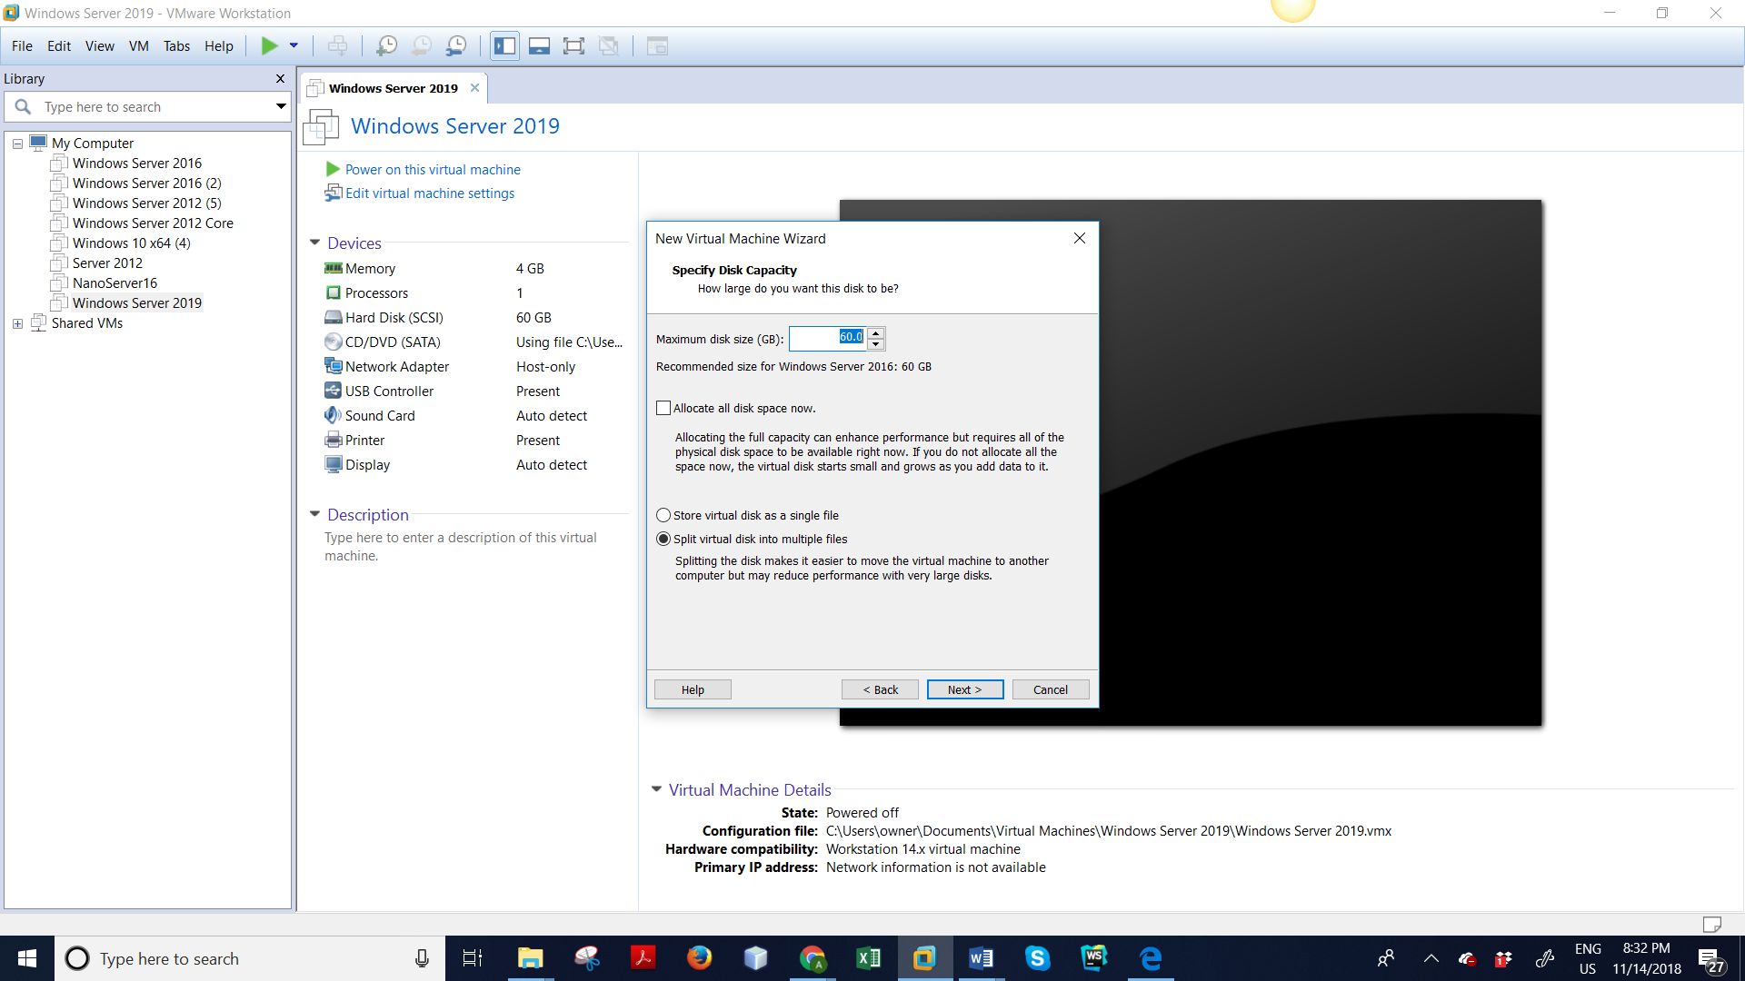

Now name the server as ‘Server 2019’

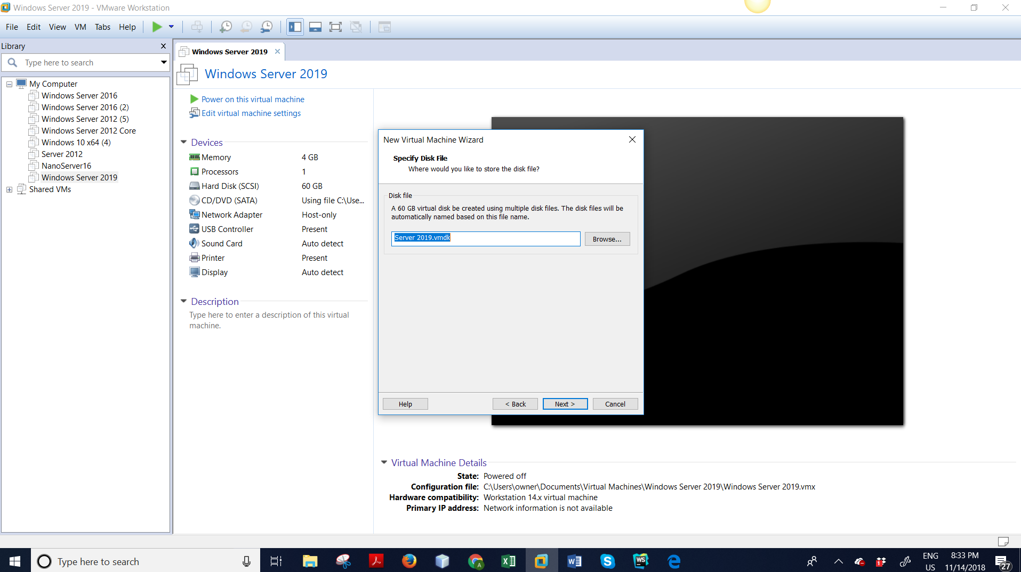

Now select finish

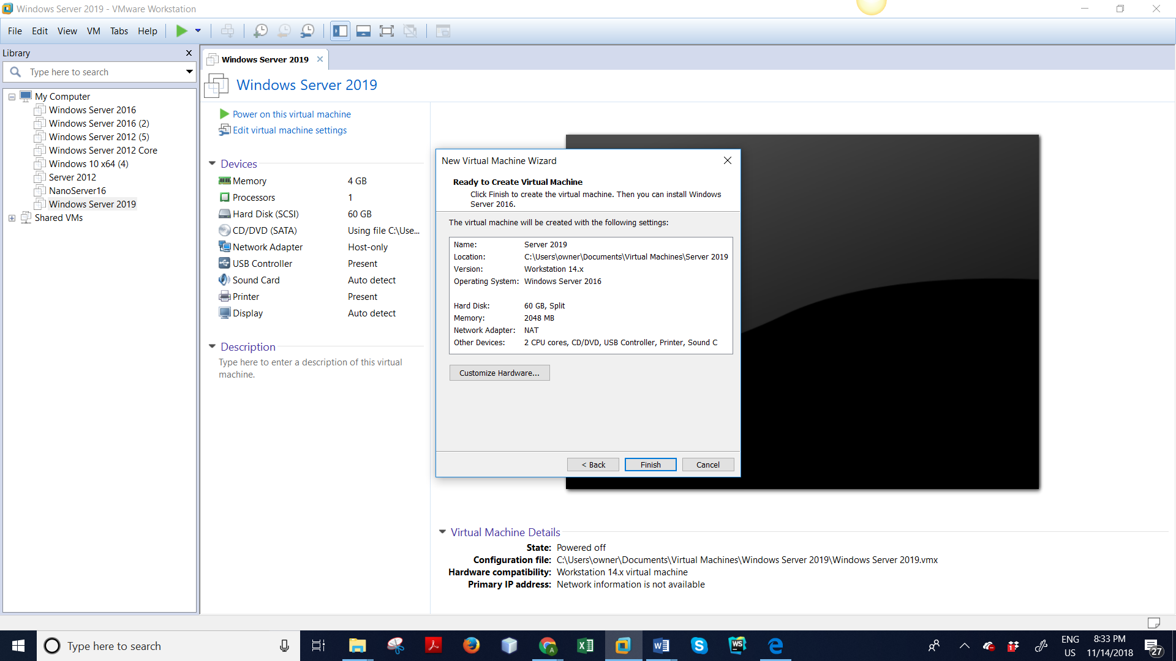

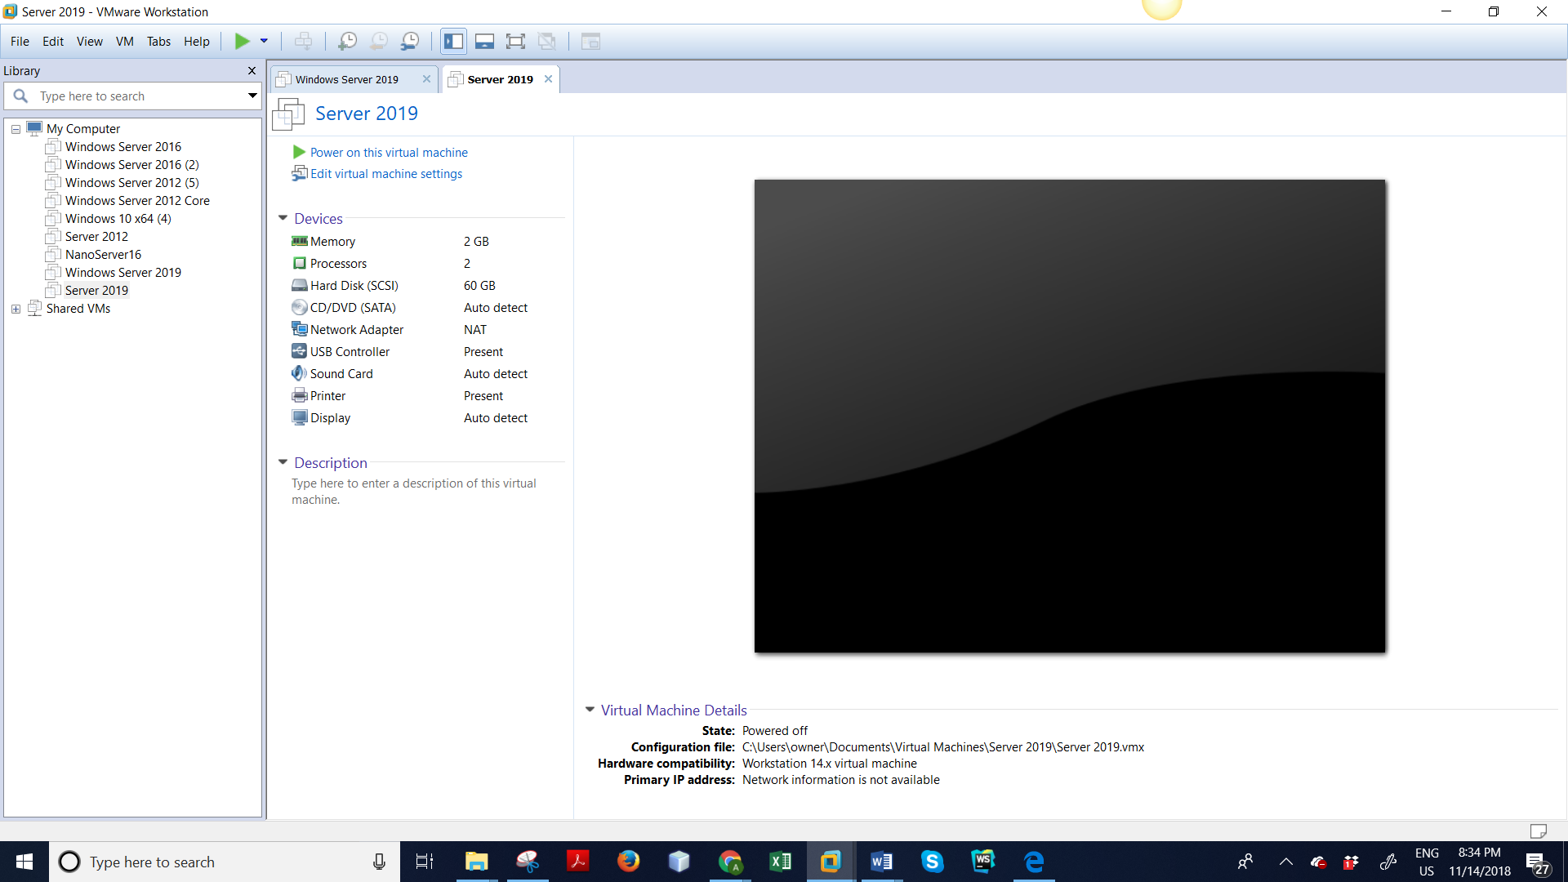

Go to edit virtual machine settings and change CD/DVD and select Use ISO image file and click OK

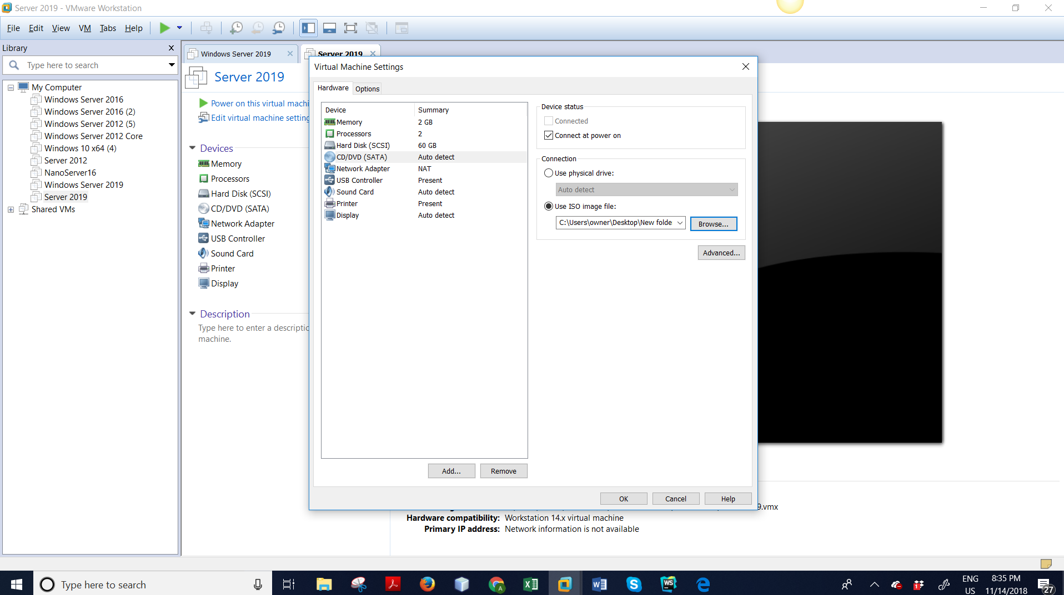

Now you will see, windows is downloading

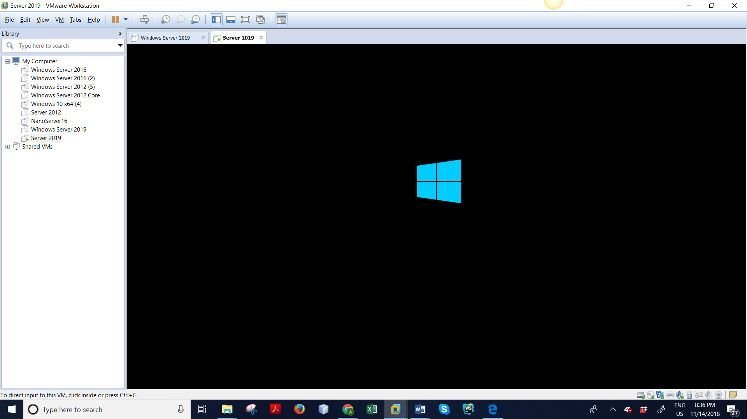

Now, select US English and click next

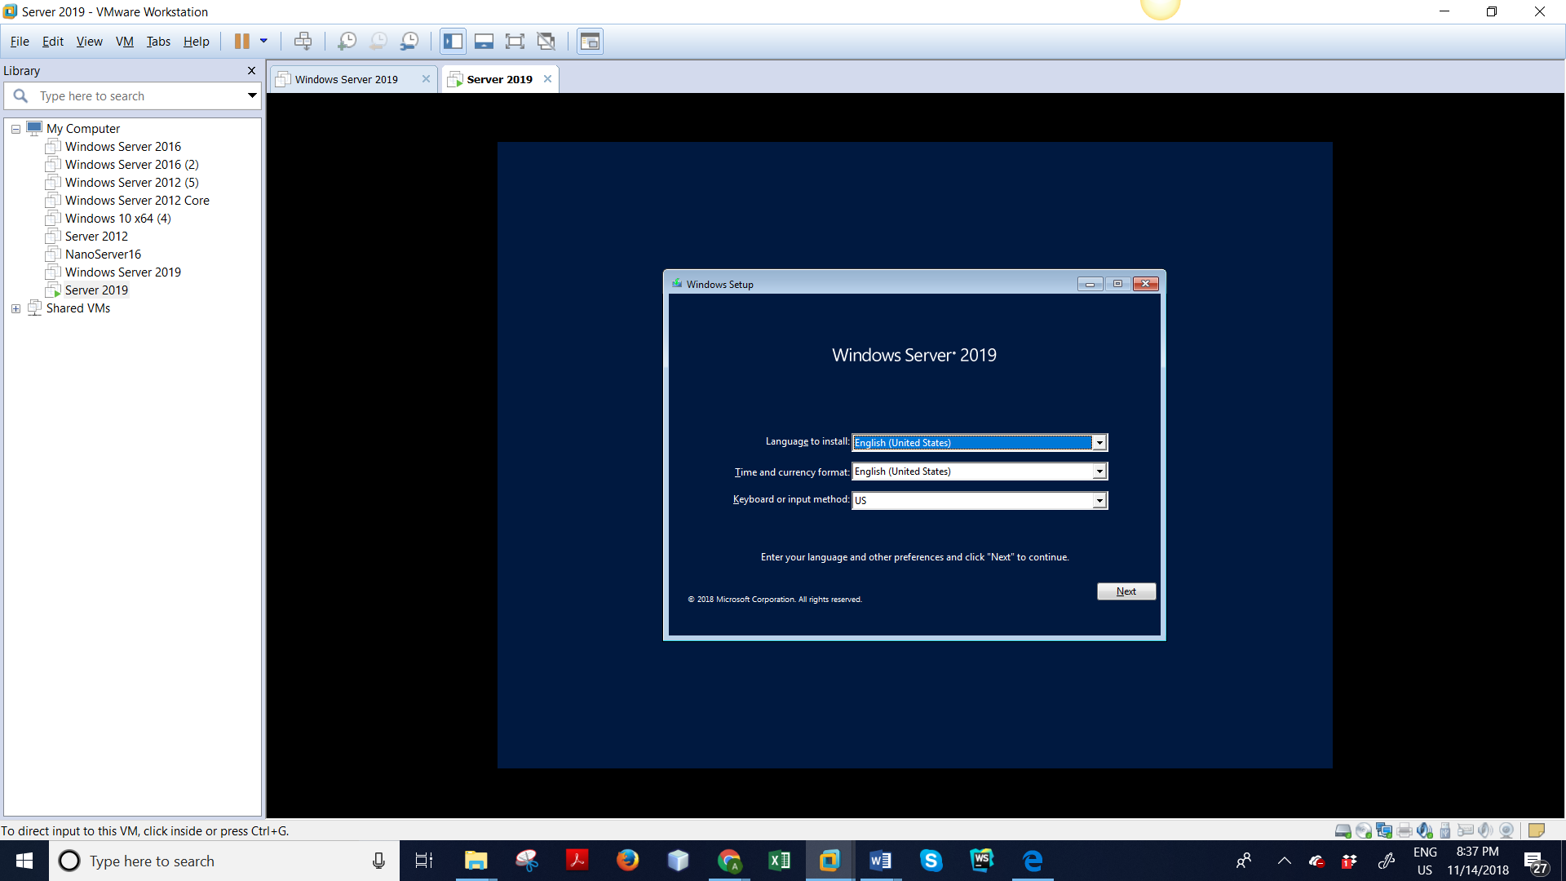

Windows Server 2019 is downloading

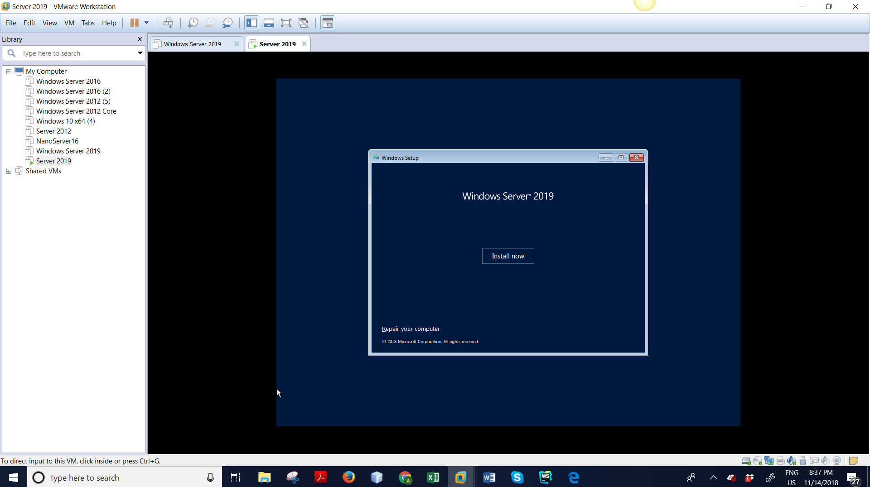

Now, select Windows Server 2019 Standard / Desktop Experience

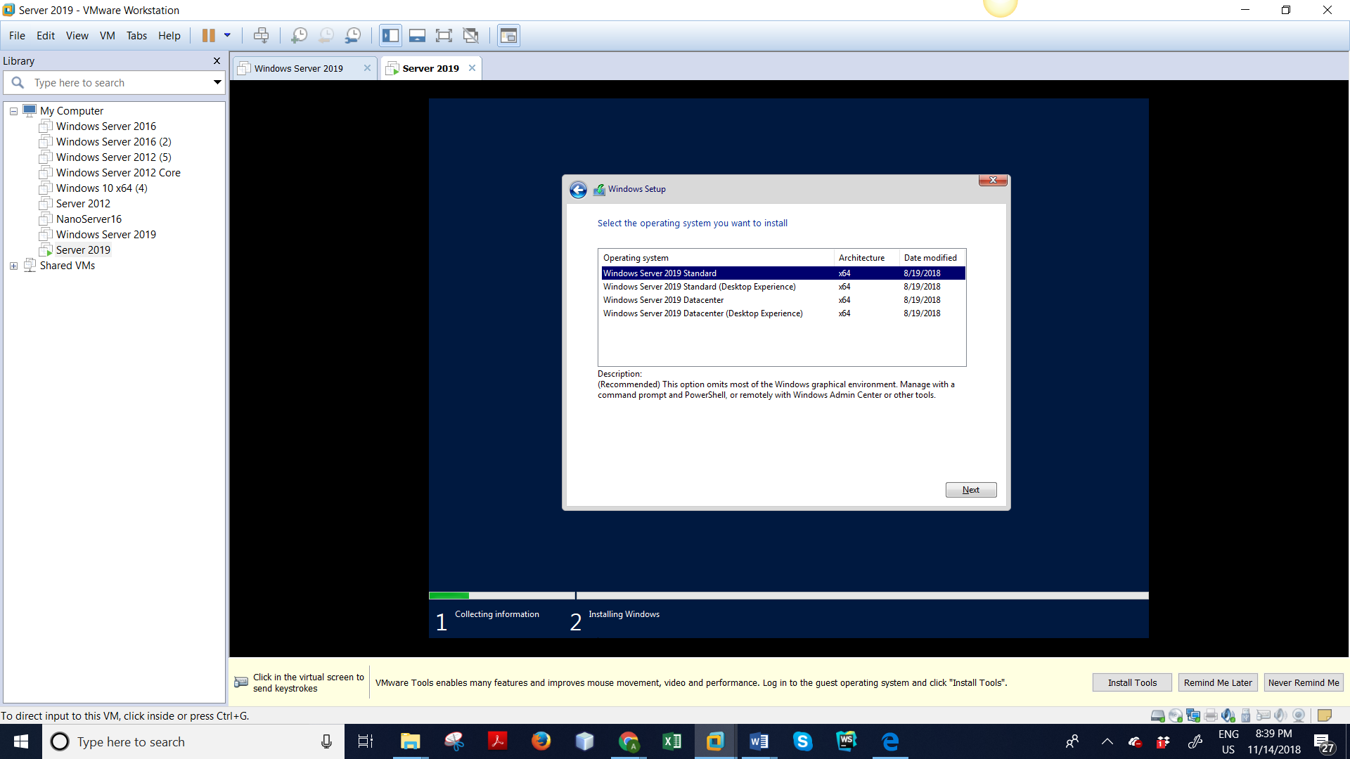

Now download windows

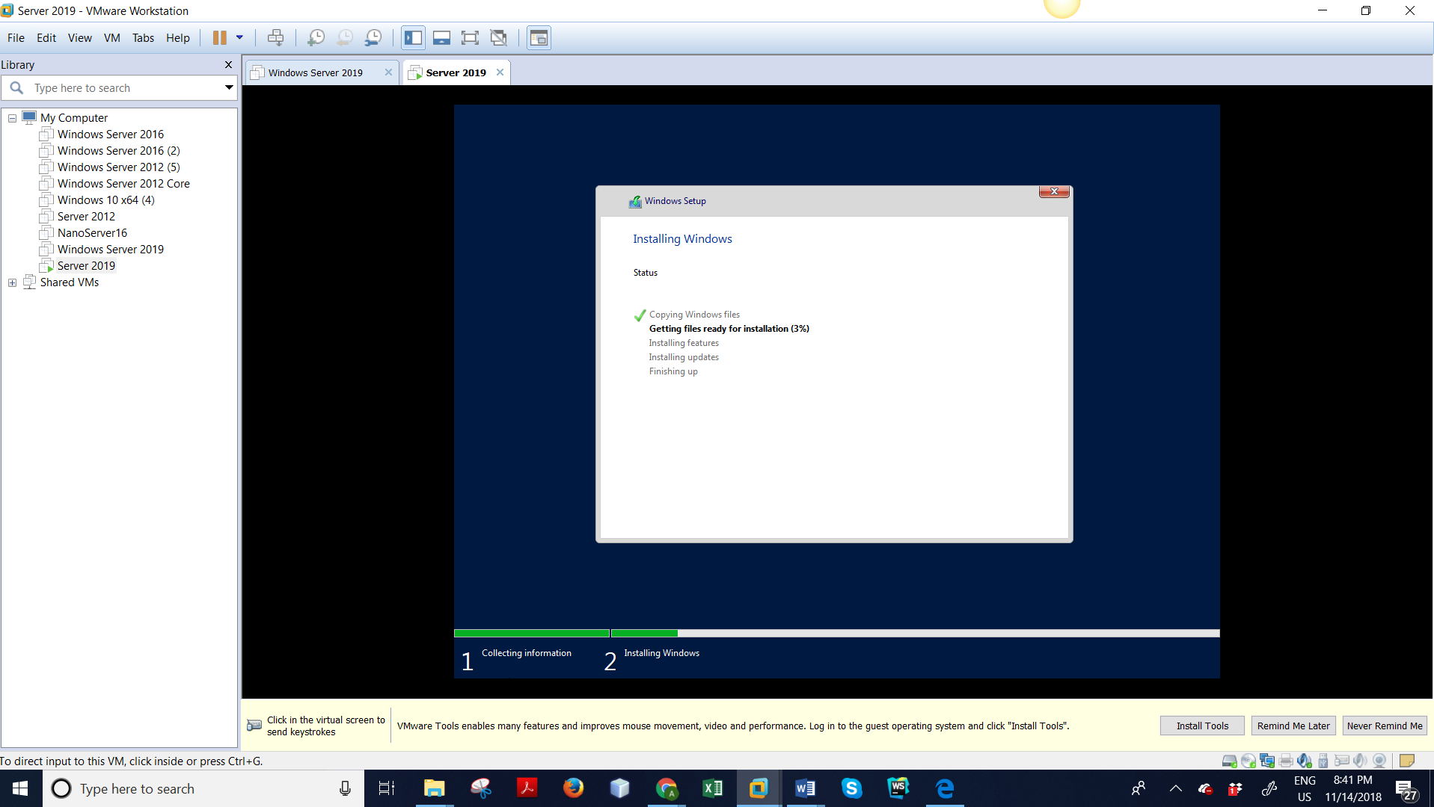

It will ask you to click ok to change password

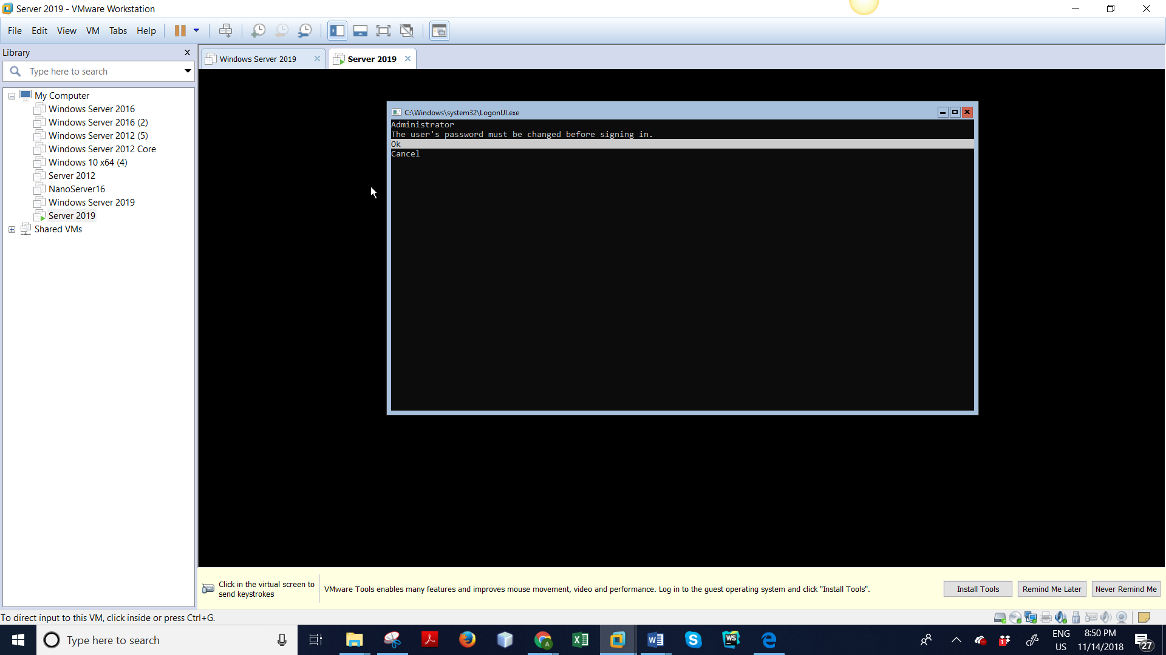

Now, change password

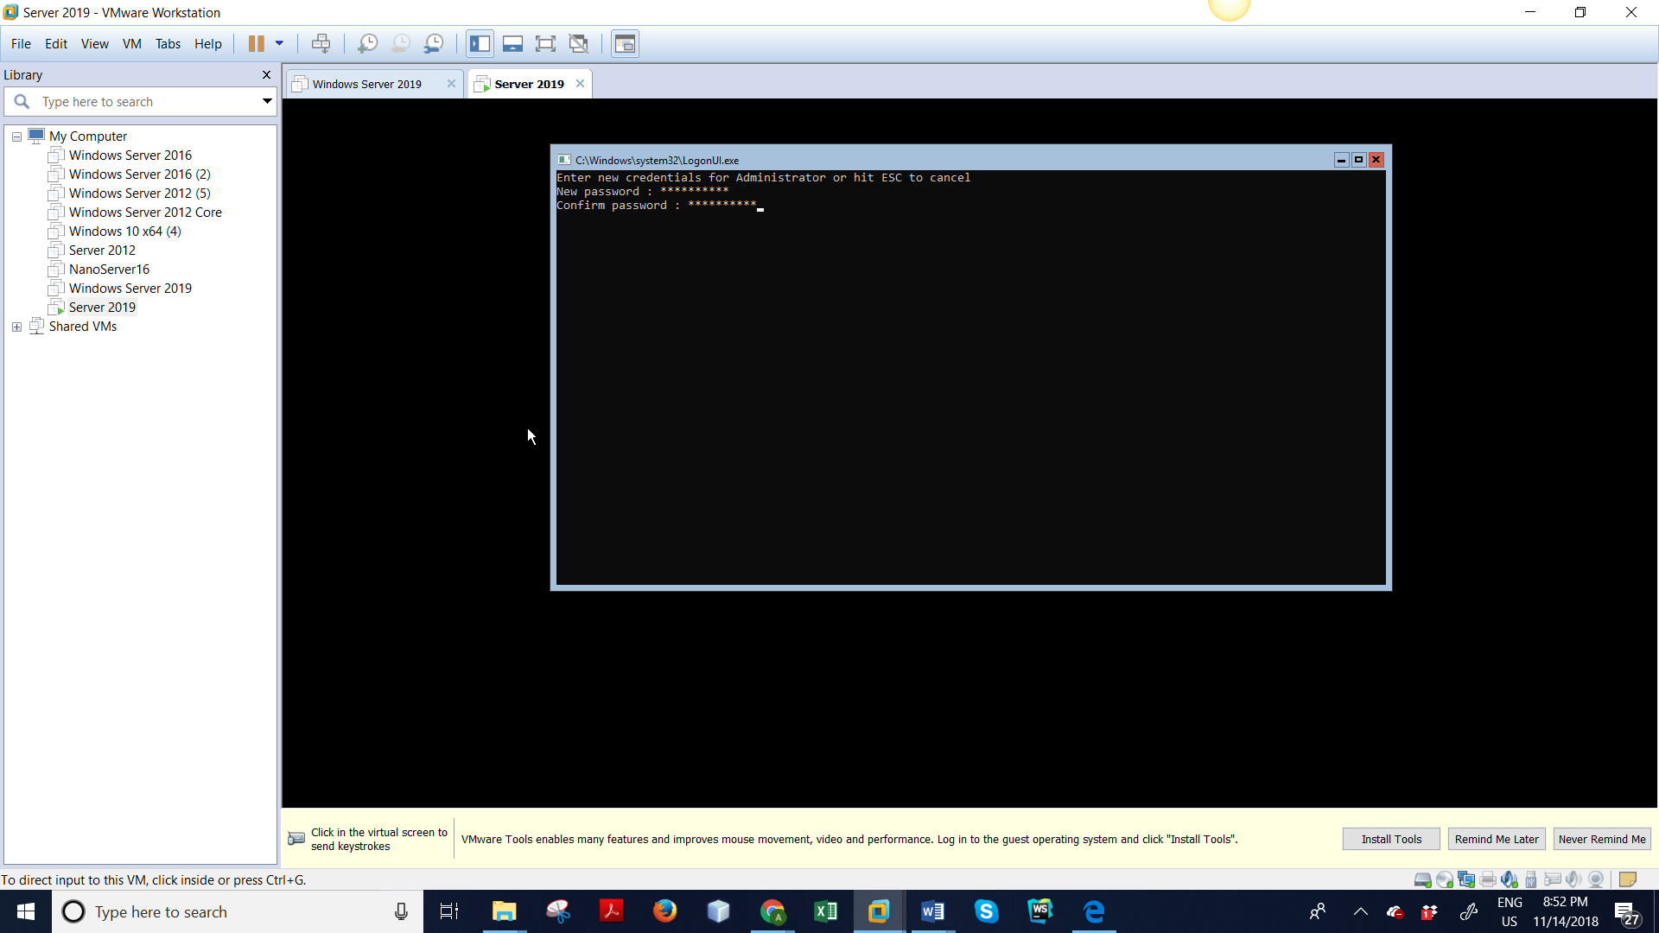

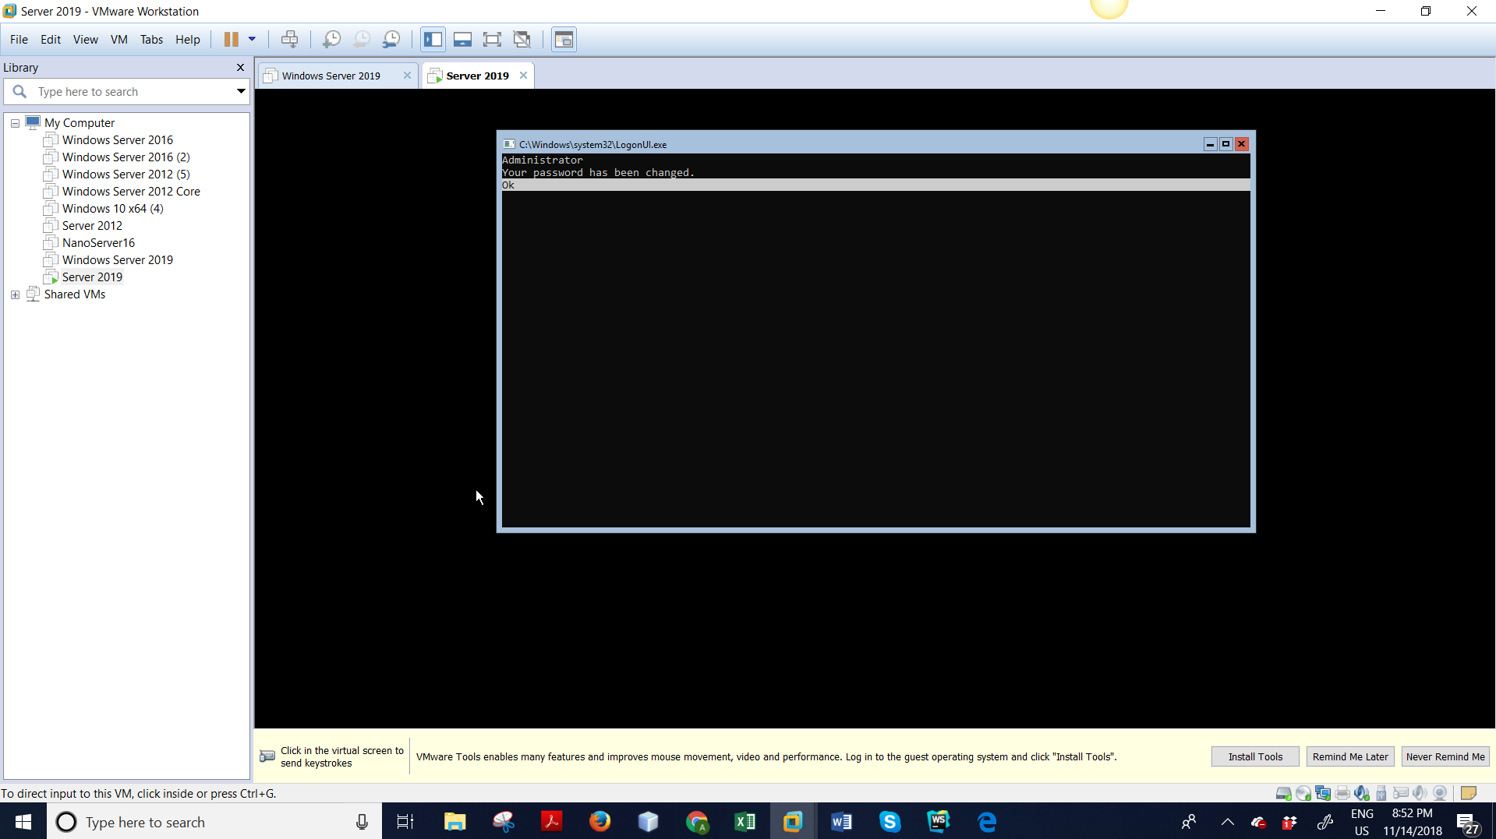

Windows Server 2019 is complete

